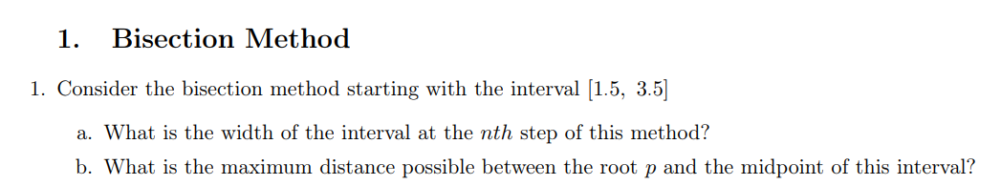

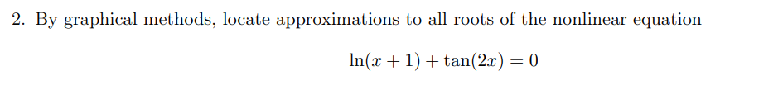

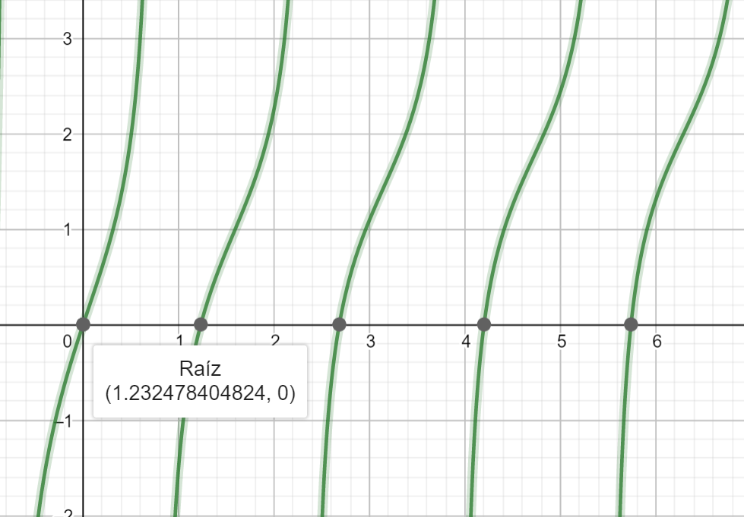

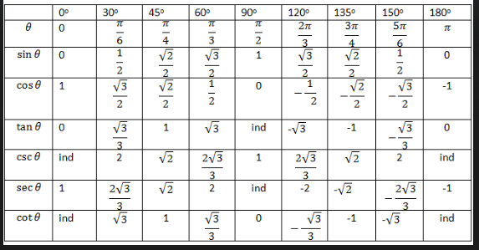

|  |  |  |  |  |  |
| --- | --- | --- | --- | --- | --- |
|  |  |  |  |  |  |
| 1 |  |  |  |  |  |

|  |  |  |  |  |  |
| --- | --- | --- | --- | --- | --- |
|  |  |  |  |  |  |
| 1 |  | 2 |  |  |  |
| 2 | 1 | 1.5 |  |  |  |
| 3 | 1 |  |  |  |  |
| 4 |  | 1.25 |  |  |  |
| 5 |  |  |  |  |  |
| 6 |  |  |  |  |  |
| 7 |  |  |  |  |  |
| 8 |  |  |  |  |  |
| 9 |  |  |  |  |  |
| 10 |  |  |  |  |  |
| 11 |  |  |  |  |  |
| 12 |  |  |  |  |  |
| 13 |  |  |  |  |  |
| 14 |  |  |  |  |  |
| 15 |  |  |  |  |  |

Una partícula comienza en reposo en un plano inclinado suave cuyo ángulo θ está cambiando en

una tasa constante dt = ω < 0. Al final de t segundos, la posición del objeto es dada por

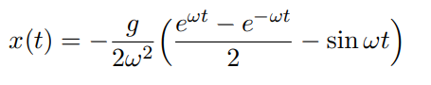

supongamos que la partícula se ha movido 1·7 pies en 1s. E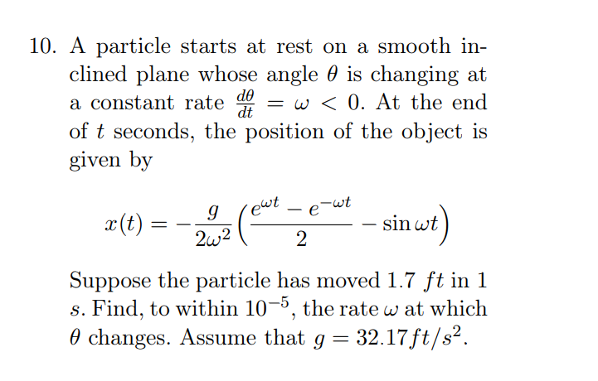

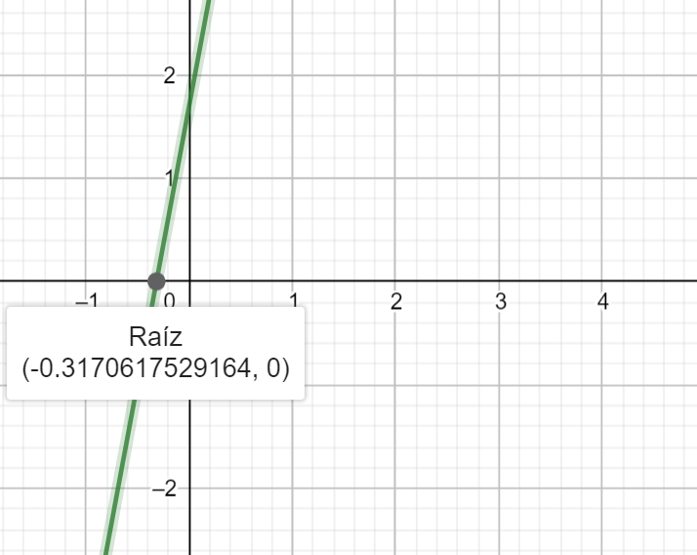

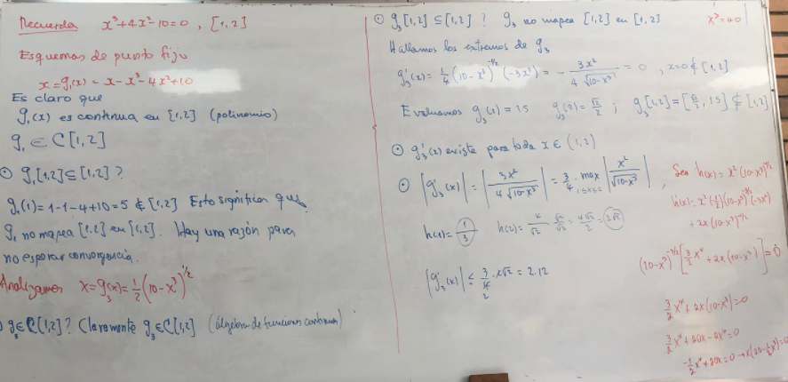

For each of the following equations, use the given interval or determine an interval [a, b] on which fixedpoint iteration will converge. Estimate the number of iterations necessary to obtain approximations accurate to within 10−5 , and perform the calculations

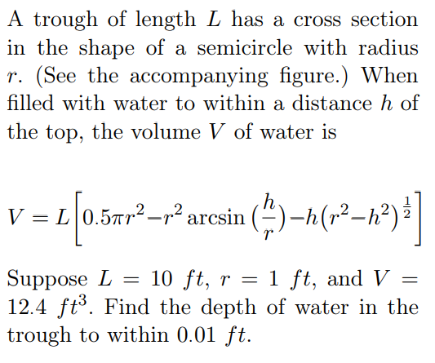

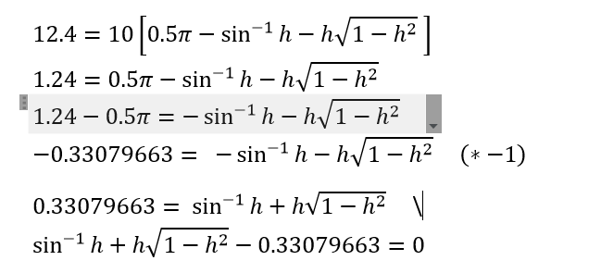

|  |  |  |  |  |
| --- | --- | --- | --- | --- |
| n | an | bn | pn | f(pn) |
| 1 | 0 | 1 | 0,5 | 0,62581548 |
| 2 | 0 | 0,5 | 0,25 | 0,16394571 |
| 3 | 0 | 0,25 | 0,125 | -0,08144858 |
| 4 | 0,125 | 0,25 | 0,1875 | 0,041995 |
| 5 | 0,125 | 0,1875 | 0,15625 | -0,01957226 |
| 6 | 0,15625 | 0,1875 | 0,171875 | 0,01125397 |
| 7 | 0,15625 | 0,171875 | 0,1640625 | -0,004149 |
| 8 | 0,1640625 | 0,171875 | 0,16796875 | 0,00355508 |
| 9 | 0,1640625 | 0,16796875 | 0,16601563 | -0,00029631 |
| 10 | 0,16601563 | 0,16796875 | 0,16699219 | 0,00162955 |
| 11 | 0,16601563 | 0,16699219 | 0,16650391 | 0,00066666 |
| 12 | 0,16601563 | 0,16650391 | 0,16625977 | 0,00018518 |

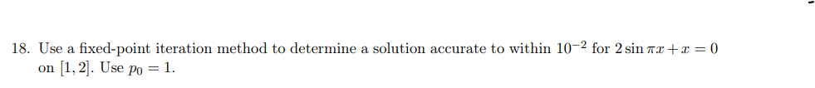

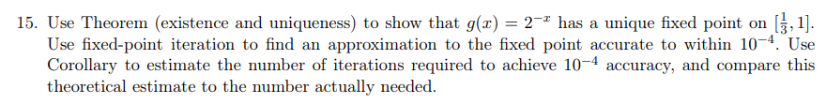

|  |  |
| --- | --- |
|  |  |
| 1 |  |
| 2 |  |
| 3 |  |
| 4 |  |
| 5 |  |
|  |  |
|  |  |
|  |  |
|  |  |
|  |  |
|  |  |
|  |  |